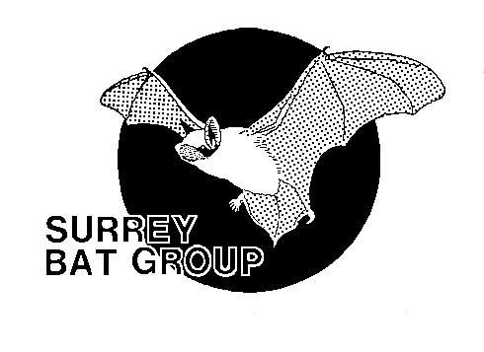
Ross Baker
4 Locke King Close,
WEYBRIDGE,

The Current Status of Rare Bats in Surrey

Authors: Ross Baker & Lynn Whitfield
Version: 3.0 issued January 2023

Introduction
This document considers the status of all Habitats Directive Annex II species in Surrey:
- Greater horseshoe bat – Rhinolophus ferrumequinum
- Lesser horseshoe bat – Rhinolophus hipposideros
- Bechstein’s bat – Myotis bechsteinii
- Barbastelle – Barbastella barbastellus
as well as two other species that are regarded nationally as very rare:
- Grey long-eared bat – Plecotus austriacus
- Alcathoe bat – Myotis alcathoe
The document looks at the current known distribution of each species within the county and, where relevant, provides high level distribution maps for each. These maps show where the species has been recorded at the tetrad i.e. 2X2 kilometre scale. Separate maps show the core sustenance zones (CSZ) for each species based on the currently identified maternity roost sites for each, and using the CSZ radius for each species published on the Bat Conservation Trust website (BCT, 2020) unless otherwise stated.
The purpose of this document is to assist ecologists and planners working in the county and to make them aware of where the most important species are present (based on current knowledge) so that they can be adequately considered in the design of surveys and the interpretation of results at a landscape scale. It is intended that this document will be reviewed and updated at least annually.

Greater Horseshoe Bat
There are no modern records for the species in Surrey. A single adult female was present in a hibernation site in Westhumble mine from November 1993 until February 1997. A single bat was also recorded in an old limekiln at Seale in September 1998. In recent years a small population has been identified in West Sussex and in 2019 there were detector records for the species in Kent. One of the bats hibernating in West Sussex in 2019/20 is known to have been born in the well studied Woodchester Mansion colony in Gloucestershire. It has been speculated (F. Greenaway pers. comm.) that the North Downs may be an important commuting route for this species, and it is certainly possible that Surrey could be repopulated from the Sussex population.
Lesser Horseshoe Bat
There are records for this bat in the east of the county in the 1950s and a suggestion that they may have been in the Haslemere area in the early 1960s, but they are currently regarded as extinct within Surrey.

Bechstein’s Bat
Surrey currently supports a healthy population of this species, particularly to the south of the county along the border with West Sussex from Haslemere to Charlwood, where there are a number of sites where either adult females have been trapped during surveys, or roosts have been discovered and studied. It has been demonstrated (Greenaway & Hill, 2008) that if an adult female, or juvenile of either sex, has been found in a suitable woodland during the summer breeding period, then it is certain that a colony is present.

Bat Group surveys carried out in 2021/2 have shown that the Chiddingfold Forest colonies east of Dunsfold (shown in Figure 2) are still present in good numbers. A distribution map which includes hibernation and swarming sites for the species is shown in Figure 1. Maps showing CSZs based on known breeding colonies are presented in Figures 2-5.

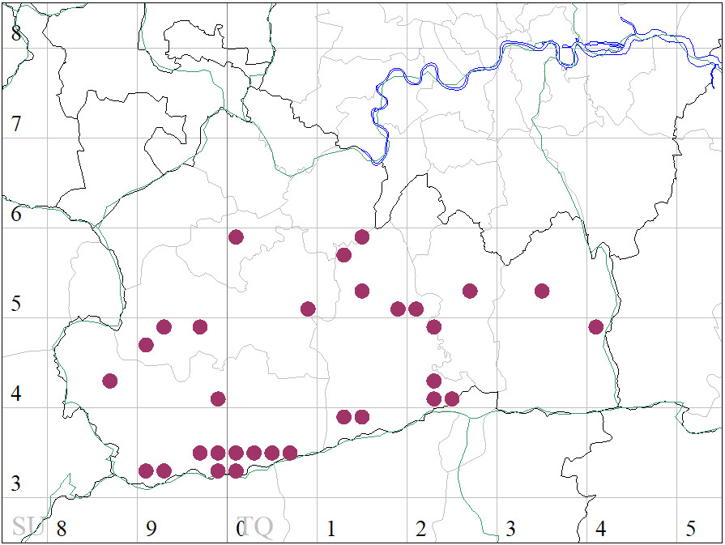
Fig 1 Distribution of Bechstein’s bat in Surrey as at Jan 2023

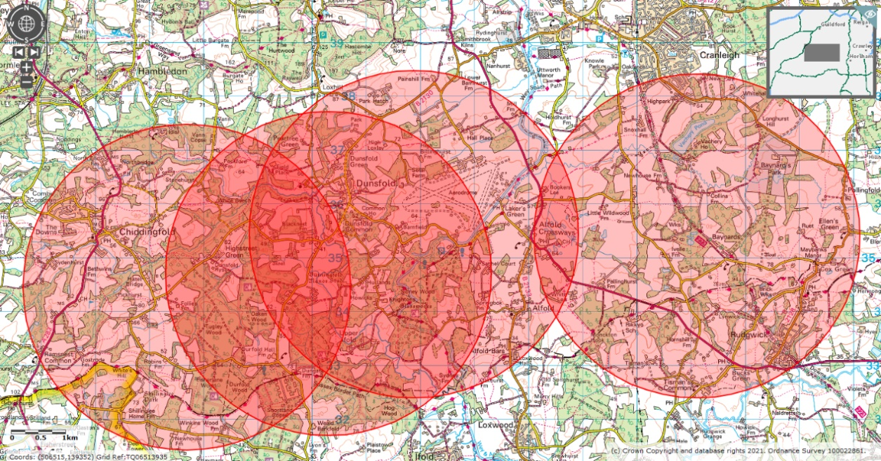
Fig 2 Dunsfold area Bechstein’s CSZs

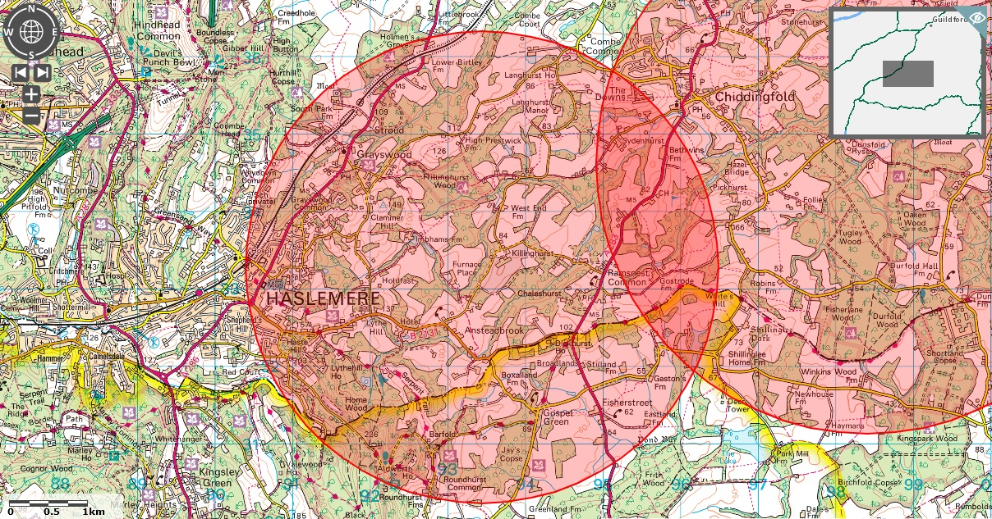
Fig 3 Haslemere Bechstein’s colony CSZ with Dunsfold to the east

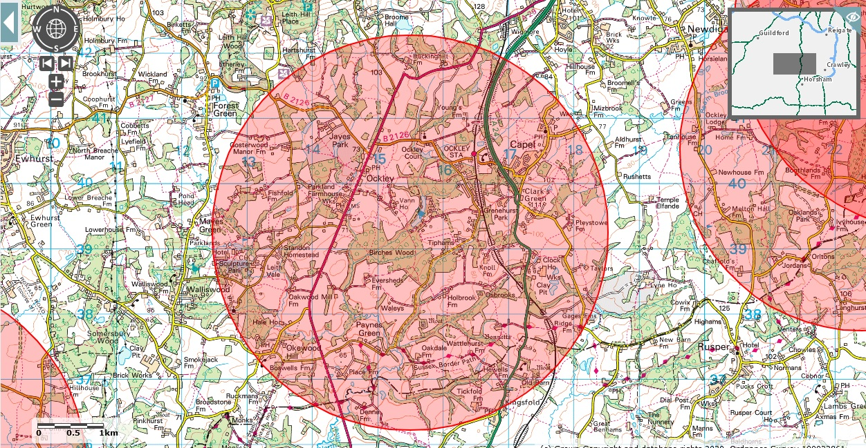
Fig 4 Vann Lake Bechstein’s CSZ with Chiddingfold Forest to west and Gatwick to east

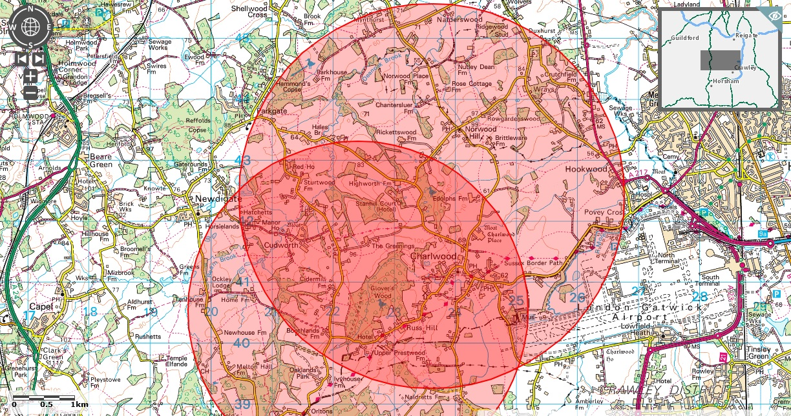
Fig 5 Gatwick Bechstein’s bat CSZs

Barbastelle
This is another species that has been widely recorded across the county, but until recently there were no maternity roost records. That situation changed in 2019 when Surrey Bat Group discovered at least two sub-groups in the Chiddingfold Forest complex. Initially it was hypothesised that these were part of a new colony, but further work carried out in 2022 has shown them likely to be new sub-groups of the Ebernoe super colony. The same work also identified a further sub-group just over the border in West Sussex and so an additional CSZ has been added to Figure 7. In previous years the group also gathered a substantial body of detector records to indicate the likely presence of a further colony just over the border with Hampshire, using the Alice Holt Forest complex. It is also possible that a third colony is present in the Albury area, but this is currently too speculative to consider demarcating a CSZ. The current known distribution of records is shown in Figure 6, and the CSZ for the known maternity roosts in Figure 7.

The CSZs used below are still based on the BCT recommendation of
6 kilometres; however, all of the bats radio tracked in Surrey to date have travelled greater distances, typically in the range of 10-12 kilometres.

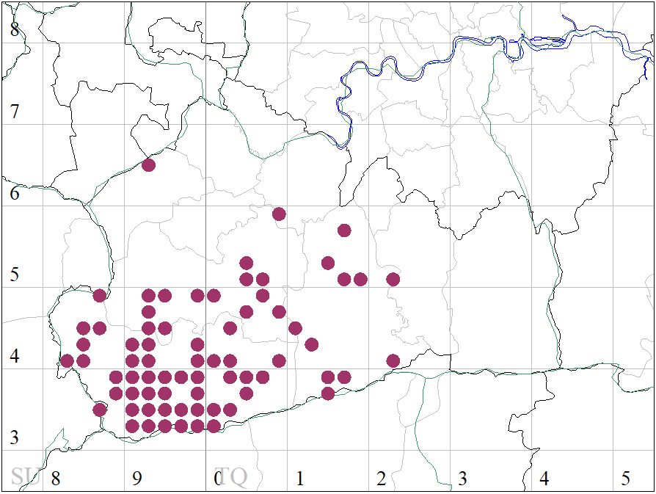
Fig 6 Distribution of barbastelle bat in Surrey as at Jan 2023

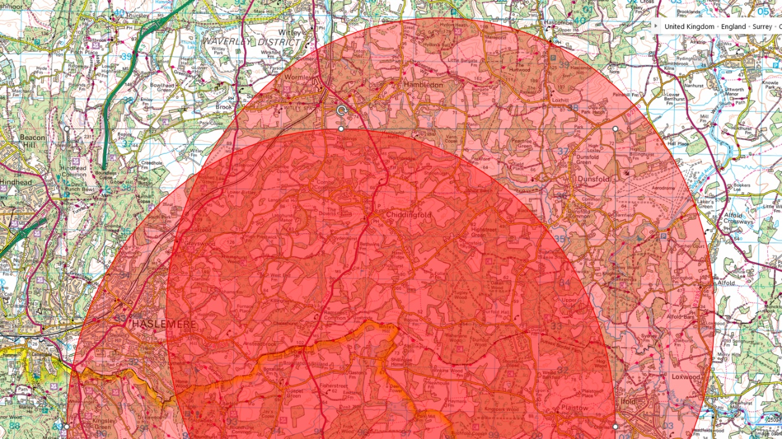
Fig 7 Northchapel and Dunsfold barbastelle CSZs

Grey Long-eared Bat
There are no confirmed records for the species in Surrey. However, habitat modelling (Razgour et al., 2013) suggests suitable habitat may be present along the Sussex border and so commercial survey work between the border to the south and the Greensand Ridge to the north should ensure the accuracy of species identification either by in-hand examination or through DNA testing of droppings.

Alcathoe Bat
This species was new to science in 2001 and was first reported as being present in the UK in 2010 (Jan et al., 2010) with records published for Yorkshire and West Sussex. It forms part of a species complex with whiskered Myotis mystacinus and Brandt’s bat Myotis brandtii. Since first being described in the UK, reliable, DNA confirmed, records outside of SE England have been sparse and survey work that has been done points to Surrey and West Sussex as being at the centre of the UK range. Current records for Surrey are shown in Figure 8.

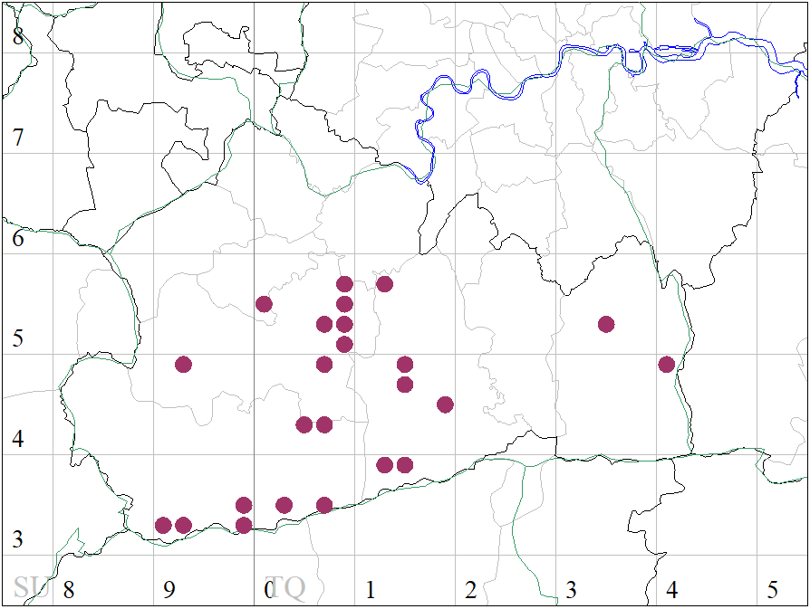
Fig 8 Distribution of Alcathoe bat in Surrey as at Jan 2023

The BCT guidelines give a 1 kilometre CSZ radius for all species in the whiskered bat complex; however, there are no published studies confirming this figure for Alcathoe. Our own fieldwork and that carried out in Sussex (Daniel Whitby pers. comm.) indicates this figure may be a little conservative for Alcathoe and so we have applied the precautionary principle in our decision to use 2 kilometres for the CSZ radius (see Figures 9 – 15). Following fieldwork in 2022 three new CSZs have been added to this version – East Horsley, Dorking and Chiddingfold.

Across its known European range the species is regarded as a woodland bat and so we have used the same criteria as Bechstein’s bat to identify woodlands where a maternity roost is likely to be present. However, in Surrey we also have the only known maternity roost anywhere in the world that is in a dwelling house, to the east of Haslemere, so where small Myotis bats are detected during surveys it is essential they are identified to species, preferably by DNA testing of droppings. Furthermore, although Brandt’s bat appears to be relatively common in the north of England it should be borne in mind that this species is rare across the south of the country (SBG data and Fiona Matthews pers. comm.), and this apparent scarcity reinforces the need for accurate identification where members of the complex are thought to be present.

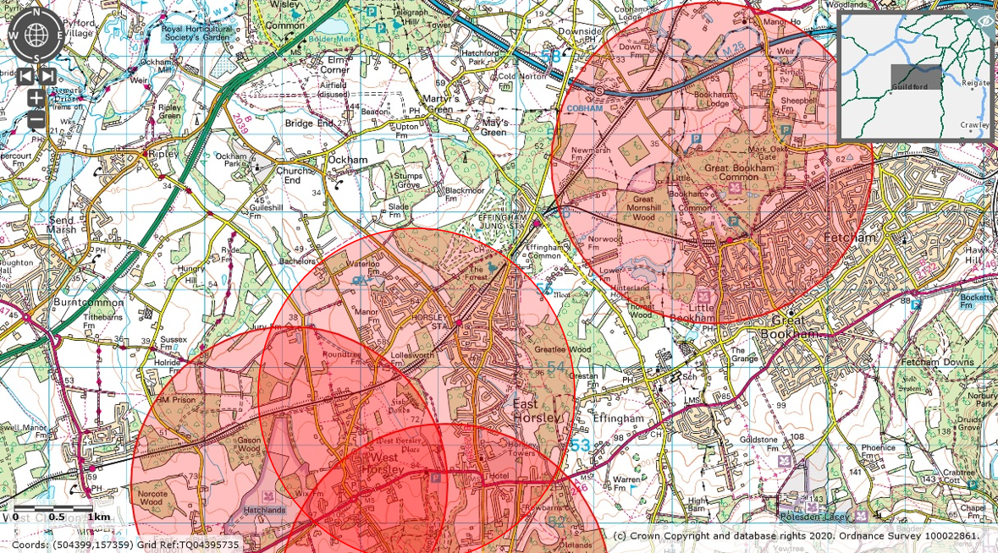
Fig 9 Bookham and part of Horsley Alcathoe CSZs

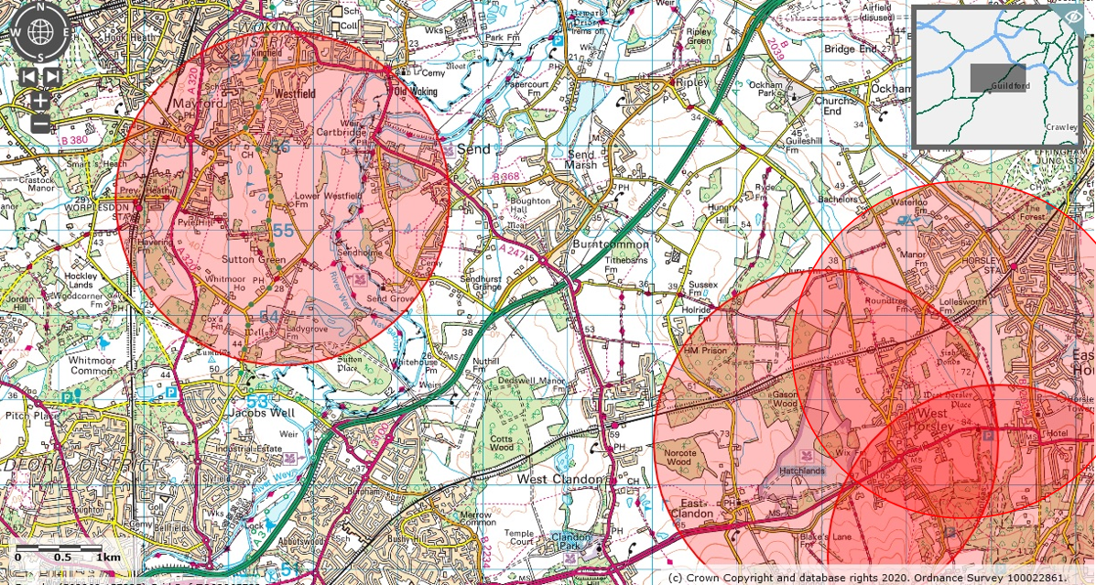
Fig 10 Woking and part of Horsley Alcathoe CSZs

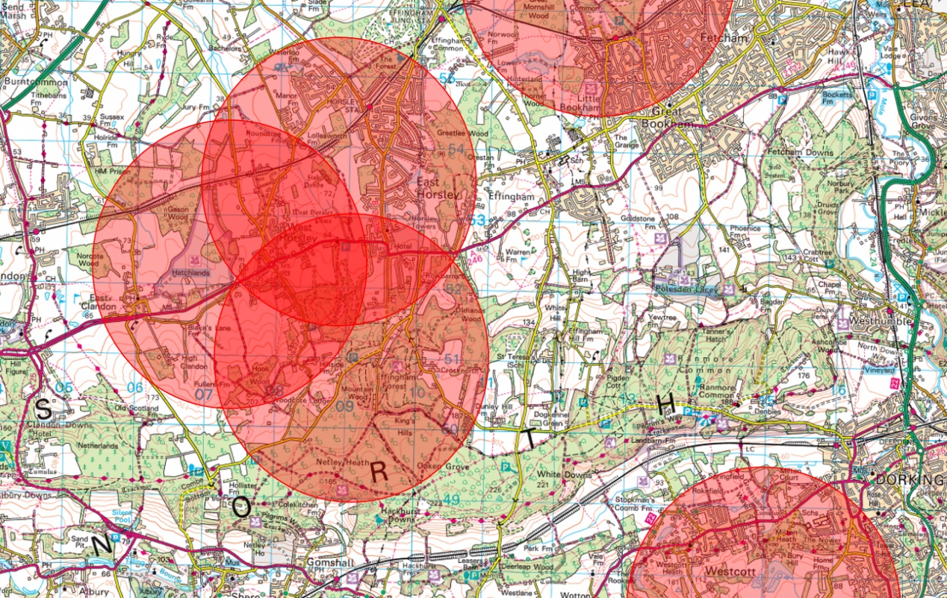
Fig 11 Horsley Alcathoe CSZs

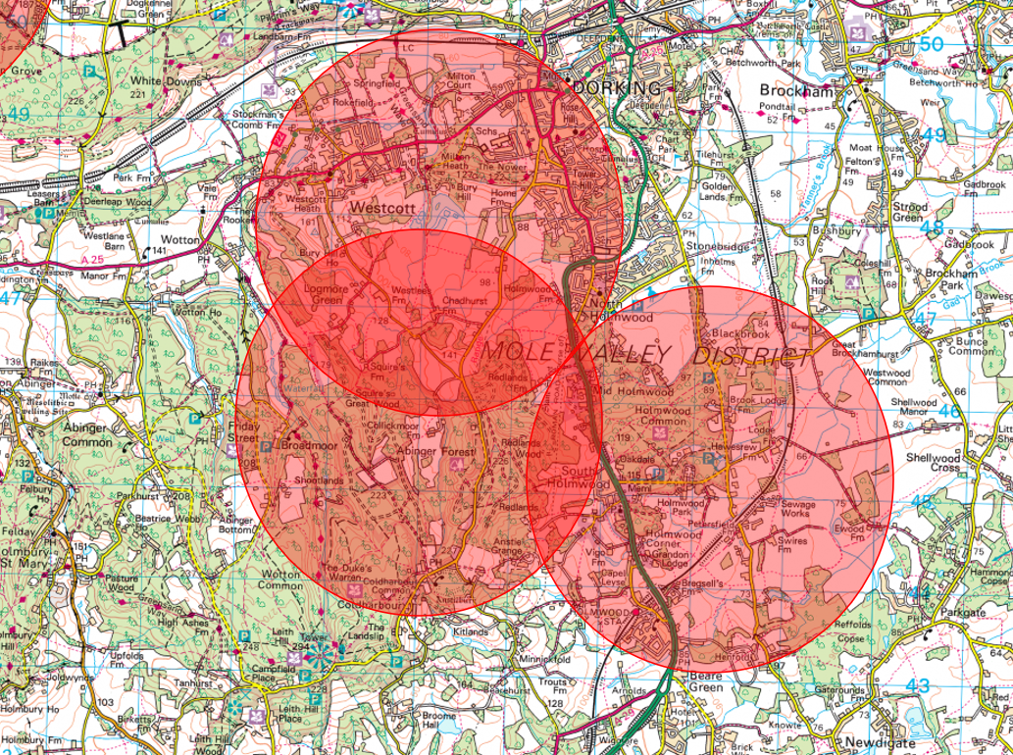
Fig 12 Dorking Alcathoe CSZs

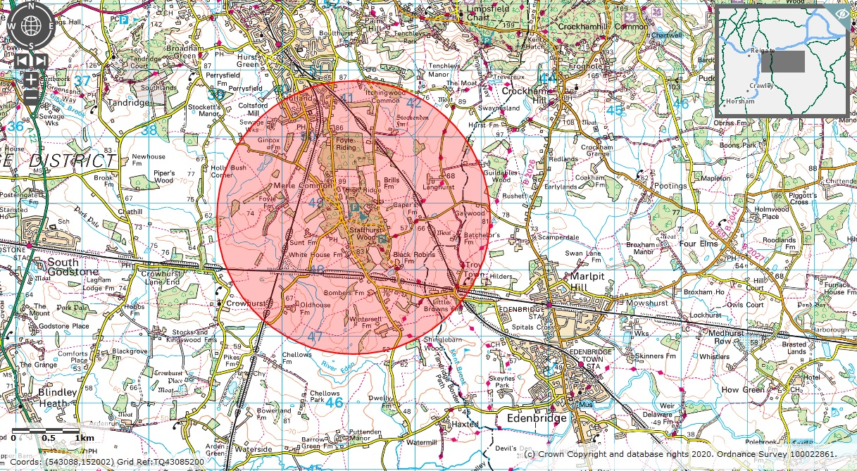
Fig 13 Staffhurst Wood Alcathoe CSZ

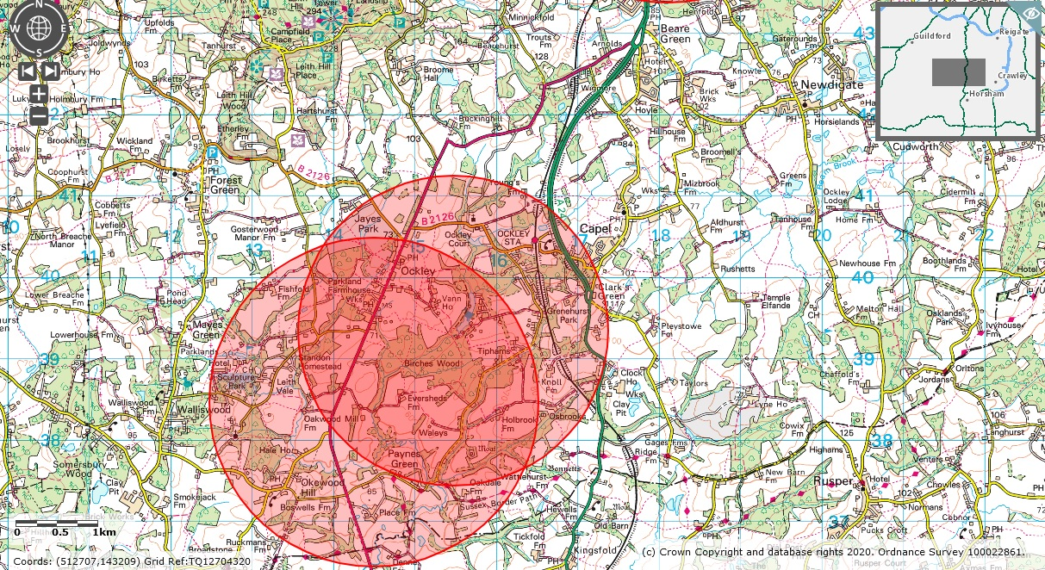
Fig 14 Vann Lake Alcathoe CSZs

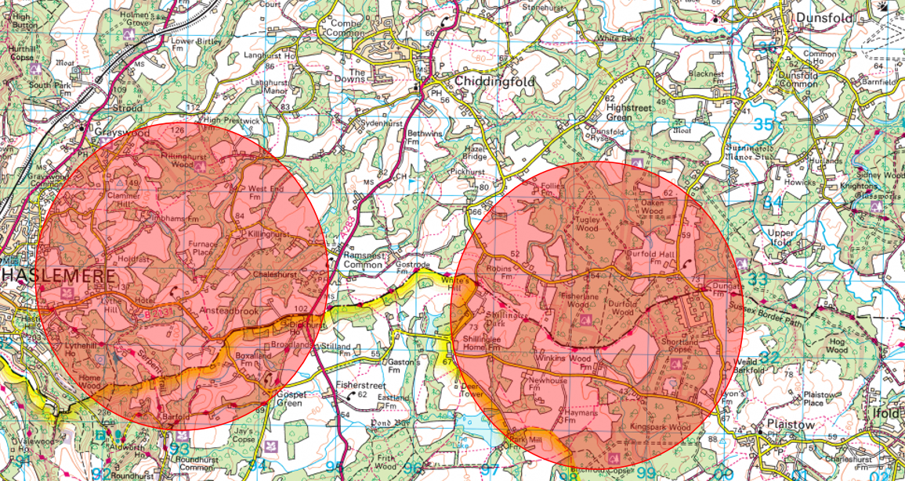
Fig 15 Haslemere and Chiddingfold Alcathoe CSZ

References

Bat Conservation Trust (2020). https://www.bats.org.uk/our-work/landscapes-for-bats/core-sustenance-zones

Jan, C., Frith, K., Glover, A., Butlin, R., Scott, C., Greenaway, F., Ruedi, M., Frantz, A., Dawson, D., & Altringham, J. (2010). Myotis alcathoe confirmed in the UK from mitochondrial and microsatellite DNA. Acta Chiropterologica 12, 471-483.

Greenaway, F. & Hill, D. (2008). Conservation of bats in British woodlands. British Wildlife 19, 161-169.

Razgour, O., Whitby, D., Dahlberg, E., Barlow, K., Hanmer, J., Haysom, K., McFarlane, H., Wicks, L., Williams, C. & Jones, G. (2013). Conserving grey long-eared bats (Plecotus austriacus) in our landscape: a conservation management plan. Available to download from the Bat Conservation Trust website: http://www.bats.org.uk/

